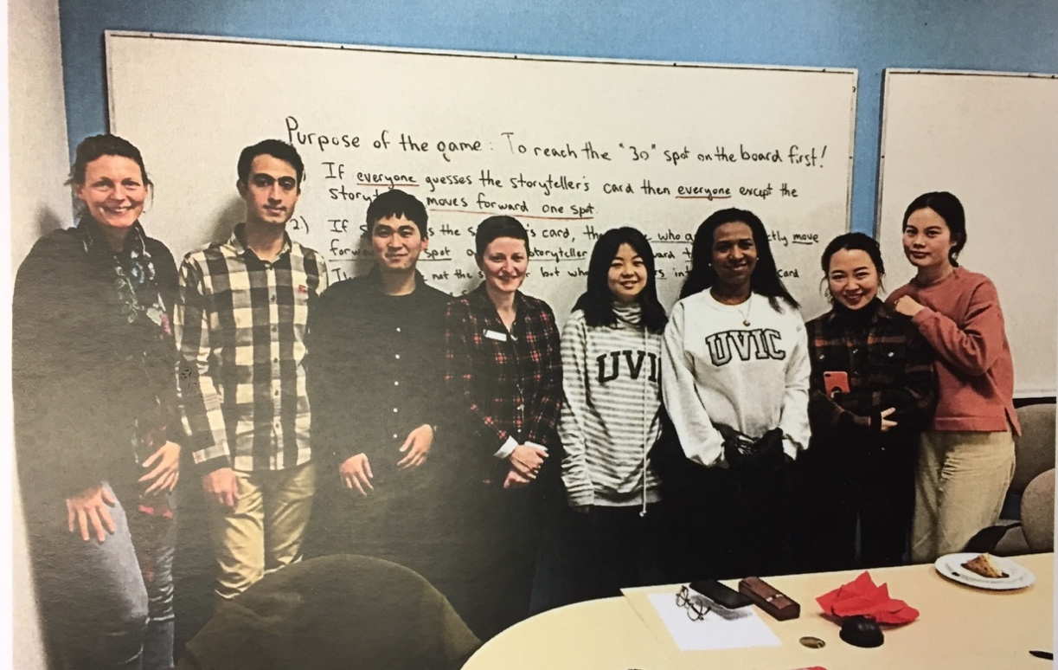  ACCESS ENGLISH CONVERSATION CAFÉ  FREE Integrative Learning Series  June 15 to July 18, Spring 2022  The Academic Critical Communication in English Seminar Series (ACCESS) is an opportunity for all UVic students with English as an additional language to improve their ability to read and communicate in English within an academic context. Participants will practice reading, listening, writing, and discussion skills in a relaxed atmosphere, receive coaching on vocabulary use and pronunciation, and receive tips for developing confidence in spoken English. Registration is required.  ACCESS Conversation Cafés on Mondays will take place in-person at the McPherson Library, in room 130. Please feel free to bring snacks.  Academic Skills workshops on Wednesdays are via Zoom:  https://uvic.zoom.us/j/88435031687.  For more info, contact Emily at cacpc@uvic.ca | JUNE-JULY SCHEDULE  Weds June 15, 12-1pm  Self-Editing Strategies  Zoom workshop  Mon June 20, 12-1pm  Café: Writing Skills  McPherson Library 130  Weds June 22, 12-1pm  Speaking to Colleagues  Zoom workshop  Mon June 27, 12-1pm  Café: Listening Skills  McPherson Library 130  Mon July 4, 12-1pm  Café: Speaking Skills  McPherson Library 130  Mon July 11, 12-1pm  Café: Reading Skills  McPherson Library 130  Mon July 18, 12-1pm  Café: Celebratory Game  McPherson Library 130

